CHAPTER 7

Basic Physics: From Quantum Mechanics to the Price of Petrol

Introduction

This chapter demonstrates how a very small number of assumptions about the structure of an atom can provide explanations, and even approximate values, for a very wide range of material properties. This arises from two results. The first is that all atomic bond energies are of the magnitude of a few electron volts and the second that all atomic spacings are about a tenth of a nanometre. This is essentially an introduction, without much detail, and is designed to remind the reader of what they have probably seen as undergraduates.

The hardest bit is that nothing makes sense if we use our understanding of the world around us to explain what happens inside atoms. Helpfully, we have illustrative examples like Schrödinger’s cat, which says that a cat in a box is simultaneously alive and dead (fig. 1). Then other experiments tell us that a photon can go through two slits simultaneously. This is useful because a sign in London Underground trains says “Use all available exits”. At least we know that it is possible to do this.



Fig. 1. Schrodinger’s cat: Simultaneously dead and alive! OUP: I DON'T KNOW WHERE THE IMAGE COMES FROM. HUGH DID THE LUL MOCKUP

It was generally accepted by physicists at the end of the nineteenth century that most things were reasonably well understood and only a few gaps needed filling-in. This proved to be a big mistake. The quantum mechanical revolution, like most advances, is not a logical sequence of discoveries and theories. It started when Planck was asked to optimise the light generated by tungsten filaments. He came up with the Planck law of how the intensity of the radiation varies with frequency and temperature, but it was essentially an empirical equation with an empirical constant h (known subsequently as Planck’s constant). However, shortly afterwards he did conclude that light must appear in discrete energies E = hf, where E is the energy, f is the frequency and h is the constant in his law. Planck was reluctant to accept this and regarded it as just a mathematical fix. He did not much like statistical mechanics and indeed does not even seem to have liked the theory that won him the Nobel Prize!

Soon afterwards Rayleigh and Jeans produced their law based on an energy kT per normal mode, which worked at low frequencies, but which implied an infinite energy in the radiation field if high frequencies were included. This showed that it was not just a question of fixing the theory with modifications, but that there was a very fundamental problem with classical physics. It was known as the ‘Ultraviolet Catastrophe’.

The photo-electric effect explained by Einstein gave a much more direct picture of physical quantities being discrete (for which another Nobel Prize was awarded). The energy of electrons ejected by electromagnetic radiation was independent of the intensity but proportional to the frequency above a certain value. On the other hand, the number depended on the intensity. This was completely inexplicable by classical physics, but entirely consistent with a picture of the light beam as a beam of particles whose energy is proportional to the frequency. It was only sometime later that this was associated with the Planck law. It is clear that there was great difficulty, even among the best physicists in the world, in coming to terms with the new ideas we know now as quantum mechanics. Apparently, Bohr, whose theory is the main subject of this chapter, did not initially believe in photons.

The second crucial result appeared when Rutherford was observing the deflection of helium ions (α particles) through a foil and suggested looking, not only at what went through, but what came back. The surprising result was that a few helium ions were detected coming in the reverse direction, which meant that that virtually all the mass of metal atoms was in an extremely small positively charged nucleus. Bohr was working with Rutherford in Manchester at the time, having found a post in the Cavendish under J. J. Thompson (who discovered the electron in 1897) to be unsatisfactory. Parallel analogy with the solar system led to the Bohr atomic theory in which negatively charged electrons rotated around a positive nucleus with the electrostatic attraction balanced by the centrifugal force.

The Bohr Theory

The major problem with this picture was that rotating electrons would radiate energy and fall into the nucleus, so some new criterion was needed to maintain the electrons in their orbits. The clue to this came from the large number of measurements of the spectral lines of elements that showed that electrons in atoms do radiate, but only at very specific frequencies. These frequencies had been measured very accurately and had been shown to obey a simple formula. In the simplest atom, the hydrogen atom, the frequency f is;

where n₁ and n₂ are integers and R is a constant. What Bohr discovered was that if the angular momentum of the orbiting electrons could only take integer values of Planck’s constant h/2π, then the difference in energy between orbits, combined with the Planck relation between energy and frequency, explained all the spectral lines of the hydrogen atom with great accuracy, and other atoms less accurately. The algebra is straightforward.

Since Centrifugal Force = Electrostatic Attraction,

and since angular momentum is quantised.

Here m is the electronic mass, v its velocity and r the radius.

We can solve these two equations for r and v, of which r is the most interesting.

This is the Bohr radius and it is indeed found to be the radius of the hydrogen atom. Even more interesting is that all atoms are about this radius. This is because electrons fill up atomic orbitals one by one, and once an orbit is full, the first electron in the next orbit sees only a single charge on the nucleus. The rest is screened by the inner electrons.
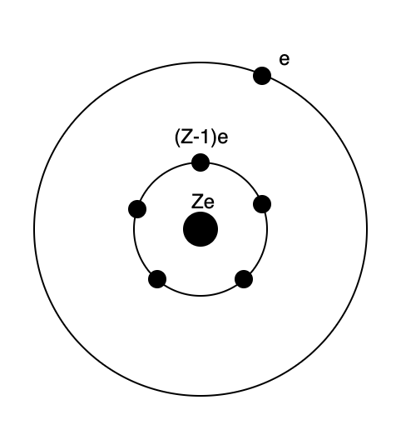
Fig. 2. The structure of an alkali metal.

An alkali metal has one outer electron that sees only one electron charge on the nucleus. Z is the atomic number.

Such an atom is one of the alkali metals (fig. 2), which include Na and K etc. Therefore, these are all much the same size as a hydrogen atom. As electrons are added, the nuclear charge seen increases so the atom shrinks slightly up to the alkihalides, when the process repeats. However, the lattice constants of nearly all elemental crystals are pretty close to 0.3 nm. This result can be related to a number of physical parameters.

- The density of an element is proportional to its atomic weight, or atomic number. Hence lead batteries are much heavier than lithium batteries;

- Specific heats of materials per unit volume are all similar, being about 3kT per atom (the Doulong and Petit Law). The specific heat per unit volume is usually more useful than the specific heat per unit mass as it determines thermal diffusivity and thermal time constants;

- The whole of our microelectronics industry depends on being able to lay down epitaxial layers on top of each other, which requires close matching of lattice parameters. This would be quite impossible if the atomic size were proportional to the number of electrons in the atom.

Atomic Energies and Bond Energies

To calculate energy levels, we just add the kinetic energy to the (negative) potential energy .

In electron volts the result for Z = 1 and n = 1 is;

It may seem an astonishing coincidence that the huge powers of ten that appear in this expression all cancel and lead to an answer of 13.6, but of course it is not a coincidence for the following reason. 13.6 eV is the energy required to remove an electron from an atom of hydrogen, or any other alkali metal. If we add the electron to a chlorine atom, where it will see a larger nuclear charge, we will get a bit more than this back, and we can then allow the atoms to come together with an electrostatic attraction and gain more energy. These contributions will not cancel-out exactly so we are left with the binding energy of an ionic solid of a few electron volts. In fact, this observation evolved the other way around. The size of the volt, and hence the size of most of the atomic constants, was based on the ionic reaction in a simple cell, so we automatically come out with a few electron volts when we calculate this energy.

The fact that Bohr obtained the correct answers for the hydrogen atom was a bit fortuitous. When a better model based on Schrödinger’s wave mechanics is used, the lowest energy state is with n = 0, not n = 1. This puts the electron on the nucleus, which would be absurd within the planetary model. This error was compensated by the fact that the angular momentum is not nh/2π but √n(n+1) h/2π. This result comes from the solution of the classical wave equation in circular co-ordinates. Bohr used the first expression given that he knew the answer he wanted and wave mechanics would not be developed until many years in the future.

The consequences of this model are far greater than the mere calculation of spectral lines. For example, it tells us that ε_{o} is the most important physical constant in explaining why we can exist, since it determines the forces that have created our world. Here are some of the other results.

Vapour Pressure of Elements

Figure 2 shows the vapour pressures of a large number of elements as a function of temperature. Since the vapour is thermally activated from the solid, or liquid, to the gas phase we expect the vapour pressure to be proportional to exp(-U/kT) where U is the activation energy, k is Boltzman’s constant and T the absolute temperature. From the above, therefore, we expect U to be a few electron volts.

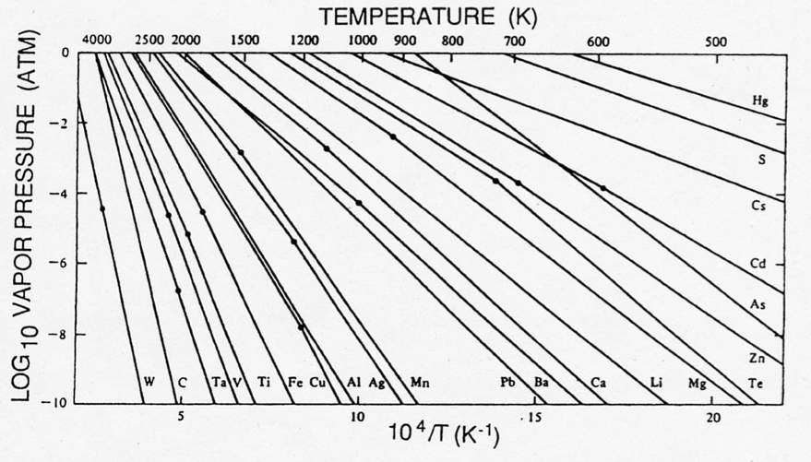

Fig. 3. log vapour pressure plotted against 1/T.
[OUP copy/pasted from https://www.chegg.com/homework-help/questions-and-answers/4-following-plot-shows-vapor-pressure-selected-elements-function-temperature--elements-lis-q45173902]

Figure 3 is an Arrhenius plot of log pressure against 1/T, which should be a straight line whose gradient gives the activation energy. This works very well. It can be seen that, although the vapour pressures vary by ten orders of magnitudes, the gradients vary by only a factor of ten. For carbon U = 8 eV and for mercury U = 0.5eV with all the other elements between them. We see that our argument that all atomic binding energies are, within an order of magnitude, a few electron volts is borne out.

What makes life on earth possible is that at room temperature kT = 1/40 eV. This allows the existence of a huge range of materials and chemical reactions. If temperatures were much higher no complex systems could exist. If much lower, nothing much would happen (although we could speculate on systems that used materials too unstable for us to make, or alternatively life using solid state diffusion, rather than liquid transport as we do. In the latter case conversation would be pretty slow!).

Battery Voltages

All batteries (or strictly individual cells) have a maximum potential of a few volts. This is because they are driven by the ionic reaction mechanism described above. We want the highest reaction potential, but this is limited by the need for a surface layer to keep the metal and electrolyte apart, so that they do not react directly, but through a current in the wire connecting them. A sodium-based battery would give a high electrical potential, but the sodium would dissolve immediately. However, lithium can be used, and is of course very light, so attractive in aircraft and computers. It does, however, have a tendency to catch fire.

Calorific Value of Fuels
Petrol is far too cheap. A reaction energy of 1 ev per atom combined with an interatomic distance of 0.1 nm gives a calorific value of 160 MJ/litre. The actual figure for petrol is 35 MJ/litre, which is in the right ballpark. (The result is very sensitive to the bond length since it is cubed. These are a bit larger than 0.1 nm, in practice).

In practice, from the second law of thermodynamics, about 30% of this energy can be transformed into ‘work’, which means a force moving a distance. This is what humans require to create our present high standard of living by cultivating the soil, transporting produce and erecting buildings. (It does not include what city bankers call ‘work’.)
Since petrol is mostly hydrogen and carbon, it is difficult to obtain a higher value than this. Petrol, and other hydrocarbons are one of the most dense ways of storing energy that exist. Most other chemicals have other atoms that do not contribute, for example TNT stores only 7 MJ/litre, while batteries need all sorts of support structures and other chemicals. It explains why it is so difficult for renewable energy sources to compete with oil.

For example, if you fill a car with 50 litres of petrol in three minutes through a 2 cm diameter hose you are transferring 3 MW with a power density of 10 Gigawatts /m². A nuclear power station generates about 1 Gigawatt and a TGV uses about 10 MW with a power density of 67 GW/m² in the overhead lines. Compare this power density with solar, 100 W/m², offshore wind, 3 W/m², and a 2 knot/m tide at 60 W/m. These figures are from ref 1. It can be seen that the difficulty and expense of collecting renewable forms of energy at a competitive rate, compared with hydrocarbons, which come rushing out of a hole in the ground, is immense. We are talking about a difference in power density of a factor 10⁸, which is not trivial. For a serious and authoritative discussion of this issue see reference (1).

If the work we do with petrol had to be done by men, as was done in Roman times with slaves, we could estimate they might produce 100 W at a minimum wage of £15 per hour. (I have doubled the actual minimum wage in the UK in 2014 since we need really strong men). The amount of petrol we need to do this costs a factor of 1000 less. Horses can produce ten times the power at a about a third of the cost but are still uneconomic, are limited in what they can do, and need a person to drive them. On this basis the value of the work available in a car petrol tank is about the same as the cost of the car.

Reaction Rates and Cooking

The change in temperature δT needed to double a reaction rate, (or any other thermally activated process) is given by the following equation;

If a rate doubles for an increase of 1 K at 300 K, it means the activation energy is 5 eV. This is the principle of the operation of a pressure cooker. It operates at 20 K above the normal boiling point of water. The water vapour pressure doubles, so the activation energy for changing water to vapour is about 0.3 eV. Cooking times go down by a factor 3, which tells us that the energies involved are about 0.4 eV, which is lower than that of ionic reactions as we would expect. Energies within living cells are even smaller so they can withstand a larger temperature reduction without stopping completely.

Elastic Modulii (excluding polymers)

If we double the distance between atoms, we greatly reduce the force between them and have put in most of the binding energy as elastic energy. Assuming approximate linearity, a volumetric strain of unity implies an elastic energy of 0.5 K where K is the bulk modulus. Putting this equal to a binding energy of 1 ev for atoms spaced 0.1 nm apart (160 MJ/m³) gives a bulk modulus of 320 GPa. This is close to the bulk modulus of tungsten, i.e. at the top end of the modulus range.

It also tells us that, since bond lengths do not vary by much, and binding energies vary by about a factor of ten, elastic modulii are similarly limited. Only lead and tin have modulii less than a tenth of this value. Also the higher the bond energy the higher the melting and boiling points, and the higher the modulii.

Alloys will have modulii somewhere between the values of the elements making them up (the so-called “rule of mixtures”). The modulus cannot be changed significantly by be-spoke heat treatment or other metallurgical processes, in contrast to the yield strength or fracture toughness, which are very structure dependent and can vary by orders of magnitude within a single alloy. However, the modulus does impose an upper limit to the yield stress. If we try to slide two rows of atoms across each other, the resisting force is the shear modulus, but spherical atoms will slot into the next spacing after a distance of a quarter the atomic spacing, i.e. a shear strain of 0.25. Hence the ideal shear yield stress of a material is 0.5 G where G is the shear modulus, typically about a third of the bulk and Young’s modulii. The best we can do in practice is about a tenth of the ideal value (an elastic shear strain of 0.025 instead of 0.25). Since the energy stored is proportional to the square of the strain, storing energy in springs is a hundred times less dense (per unit volume) than in petrol. The only exception is pure hydrostatic pressure when the limit to compression is when the atoms collapse to a neutron star. This is not practical on earth.

Band widths and Band Gaps

The electrical properties of conductors and semiconductors are determined by the energy bands containing electrons and the band gaps between them. These are about an electron volt. This is because each band is an atomic energy level broadened by the proximity of other atoms so they are about 1 ev apart. This means that transistors can work at a few volts instead of the hundred volts of the thermionic valves they replaced.

Note, however, that semiconductors do not work by activating electrons across the gap between valence and conduction bands. This is 0.5 eV for silicon so the proportion of activated electrons at room temperature is exp(–20) = 2x10⁻⁹. This is negligible. To make a transistor we dope a material with an atom that dissolves and adds an electron from an energy level close to the conduction band, or a hole close to the valence band. We can make transistors from diamonds that have a very large band gap, and they are excellent at high temperatures.

It also means we can make light emitting diodes and photovoltaic cells. Optical frequencies are between 400 and 700 nm which is 3.3 to 1.7 eV. The connection between photon energies and reaction energies of a few eV is indirect. The photon energies would be quite different if the sun were at a much higher temperature or a much lower one, but we would not be here to observe them.

The Contact Potential

The contact potential is the electrostatic potential of a metal when it is connected to earth and has a number of applications. Consider first an isolated neutral solid conductor. We take zero potential to be another conductor a large distance away, i.e. the earth. Since there is no charge on the first conductor, it follows from Gauss’ theorem there that are no lines of force emanating from it to the earth, so there is no electric field in its vicinity. Now let us bring an electron up to the body. The electron will be attracted to the conductor by its image and will therefore fall into it, charging it slightly and raising the energy of all the electrons in it. Since there are always a few electrons around in space, this process will continue until the body is sufficiently charged to repel any electrons attempting to join it. The body is then in thermodynamic equilibrium and the energy of the electrons in it is the same as those at a large distance i.e. the earth. A simpler way to achieve this state is just to connect the body to earth. The energy an electron gains as it approaches a neutral conductor is the electrostatic energy between the electron and its image until it reaches atomic distances from the surface when it is absorbed. The energy is therefore about an electron volt and an earthed conductor will have an electrostatic potential of about a volt.

This is surprising and has more implications than might appear at first sight. The fact that a metal connected to earth is charged is due to the finite size of the charge on an electron. Classical electrostatics assumes that the smallest charge available tends to zero, in which case there would be no charge on the metal. It easier to understand when we involve the electronic theory of metals when we see that the potential of an electron includes other terms than purely electrostatic ones. The simplest, although the smallest and negligible, is the gravitational force which will cause a slightly larger charge density at the lower end of a conductor and a corresponding electric field to counter the gravitational force.

If we include the quantum mechanical theory of electrons in metals different materials will have different contact potentials, and this is equal to the ‘work function’, or the energy needed to extract an electron from the metal. This determines the thermionic emission from a filament and is therefore of vital importance to thermionic valves, electron microscopes and other devices requiring electron beams. Small reductions in the work function lead to large increases in the current available.

Another result is the large voltages that can be generated by separating two materials with different work functions. Suppose we allow a large plate of zinc and a plate of copper to come into contact. If they are smooth the effective separation might be a about a micron, and the difference in electrostatic potential about 0.2 volts. If we separate them to a metre apart the charge stays constant while the capacitance of the parallel plate capacitor they form decreases by 10⁶. The potential between the plates is now 200 kV. This is one of the mechanisms by which water blown off ice in clouds can lead to large electric fields and lightning (water and ice have different contact potentials), and fluid jets in oil tanks can cause sparks that explode the tanks.

For two plates, the charge, and hence current available, is tiny, but recently nanotechnology has been used to create rough surfaces on a nanoscale that greatly increase the surface area so that useful currents and high efficiencies compared with piezo-electric devices can be obtained. These are called ‘triboelectric generators’.

The Effect of Wave Mechanics
The above discussion goes a little beyond what can reasonably be inferred from the Bohr theory although the conclusions are justified by the subsequent theory of wave mechanics of which there are more details below. However, with the basics, we can estimate the strength of a metallic bond.

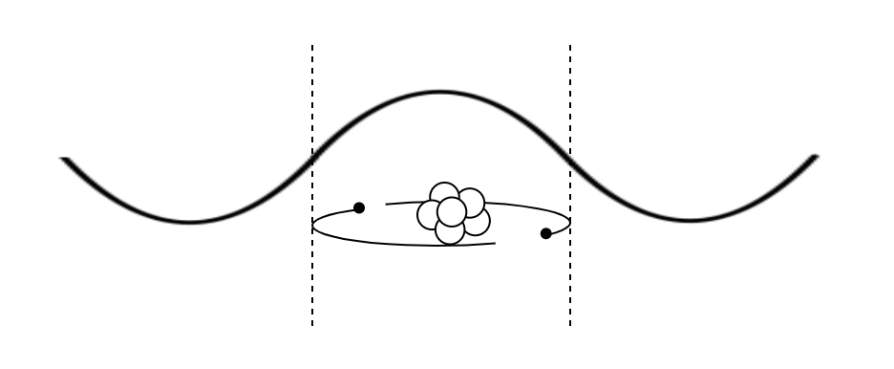
(a)


(b)

Fig. 4. Electrons moving around an atom exhibit a characteristic wave function. (a) For a single atom, this is a sinewave whose half wavelength is the diameter of the orbit. (b) For a molecule or metallic bond, the electrons have access to a wider volume hence the wavelength is longer.

The metallic bond is illustrated in fig. 4. The outer electron of two separate atoms is relatively free but confined in a box of diameter equal to the atomic diameter. The wave function is a sine wave of wavelength 4r. The momentum is mv = hλ so the velocity v = h/8mr and the kinetic energy 0.5mv² = h²/32mr², as shown in fig. 4(a). If we put two atoms together, as shown in fig. 4(b), the electrons can range over double the distance, so the energy of each is reduced by a factor of four. Therefore, the binding energy per atom is 3h²/128mr². This is 34eV and 3π²/16 times the hydrogen ionisation energy. This quantity will be reduced by the need to bring the atomic cores within an atomic distance, also a few eV. Hence metallic binding energies are also of the order of electron volts.

Covalent bonds work in a similar way. The electrons have access to a wider volume, but the increased nuclear charge and directional nature of the electron orbits means that they do not flow freely and the bonds saturate.

The following describes the main steps by which quantum mechanics was developed to explain atomic structures:

1) Quantum mechanics was unknowingly started when Planck was able to explain the spread of frequencies in black body radiation with the assumption that the energy in an oscillator could only take discrete values, E = hf;

2) The fundamental importance of this appeared when Einstein explained the photoelectric effect. The energy of the ejected electrons depended only on the frequency of the light and not its intensity. Light had the characteristics of a stream of particles, photons. The same constant that Planck had assumed as a fitting parameter appeared in this quite different situation;

3) Since the force on a solid absorbing a light beam was known from classical physics, it was possible to assign a momentum to each photon, p = hλ;

4) The only Duke to win a Nobel Prize, Louis de Broglie, proposed that the same relation between momentum and energy and wave properties applied to particles such as electrons. This was proved by electron diffraction. Sir George Thompson shared the Noble prize for showing this experimentally, which must have been very satisfying for his father, Sir Joseph, who had received it for discovering the electron was a particle. If we apply the standard condition that there must be a whole number of wavelengths round an electron orbit in an atom then 2πr = nλ = nh/mv and the Bohr condition, mvr = nh/2π drops out;

5) Erwin Schrödinger extended the idea of a beam of electrons as a wave to take account of an electrostatic potential. This is like a variable refractive material for a light beam. If the local wavelength is λ then for a wave amplitude ψ

where λ depends on the local potential. If the energy of the particle is E and its potential energy at r is V(r) then the kinetic energy is

Substituting for v in gives

This is the famous Schrödinger equation for which he also received the Nobel prize. Its solution with the electrostatic potential of the nucleus for V(r) gives all the energy levels of the hydrogen atom. With the addition of the Pauli exclusion principle, it explains the elements and the periodic table;

6) The Pauli exclusion principle is central to physics but can be obtained in a few lines. It relies on the hypothesis that all electrons are identical and therefore there is no way of telling if two have swapped places. Suppose particle 1, wave function ψ₁, is at r₁ and particle 2, wave function ψ₂ is at r₂, the probability of this occurring is ψ₁(r₁) ψ₂(r₂). However, we believe that the wave function tells us all the knowable information about the particles so this function is unacceptable since we would not know if the particles had changed places. Therefore, the true wave function must be a linear combination of this function, and the function when the particles have changed places, ψ₁(r₂) ψ₂(r₁). Since the total probabilities must add to unity, the only acceptable wave functions are;

What this means is that if we take the minus sign and ψ₁ = ψ₂ then there is zero probability of the particles being anywhere. Therefore, two particles cannot occupy the same states. This was clearly relevant to electrons in atoms that occupied different orbits. However, it seemed that to explain the periodic table, two electrons must be accommodated in each state. This was explained by the idea of an electron spin, which could be plus or minus, so that two electrons could have the same spatial wave functions but different spins. Particles with odd spins (Fermions) such as electrons, cannot occupy the same state while no such restriction applies to particles with no, or even, spins (Bosons).

We can go a little further with the Schrödinger equation. It can be solved by separation of the variables, using a power series for the radial variation and imposing the condition that the wave function is zero at infinity. This requires an integer value n to ensure the polynomial is not an infinite series. The theta and phi variations lead to variations of the form cos(kθ) where k is also an integer to ensure the wave function is single valued. This is equivalent to the condition of a whole number of wavelengths around the atom, and therefore justifies the Bohr quantisation of angular momentum. The integer n gives the number of peaks in the wave function, and as n increases the mean position moves outward, so increasing the energy. Also, the value of k is restricted to values less than n so that the ground state with n = 1 is spherically symmetric with the most likely place to find the electron on the nucleus and with k = 0. If n = 2, can we have a theta variation and more states with k = 0 or 1. If k = 1 the wave function is no longer symmetric so we can have directional bonds. n is associated with the principal quantum number of Bohr and mainly determines the energy. k is associated with his elliptical orbits and gives directional bonds. In this way the electron structure of all the elements can be explained.

The algebra involved in treating this properly is not very difficult, although a bit long, and was very familiar to the physicists of the time, since it had already been explored in great detail in analyses of the acoustic oscillations of spheres and cylinders.

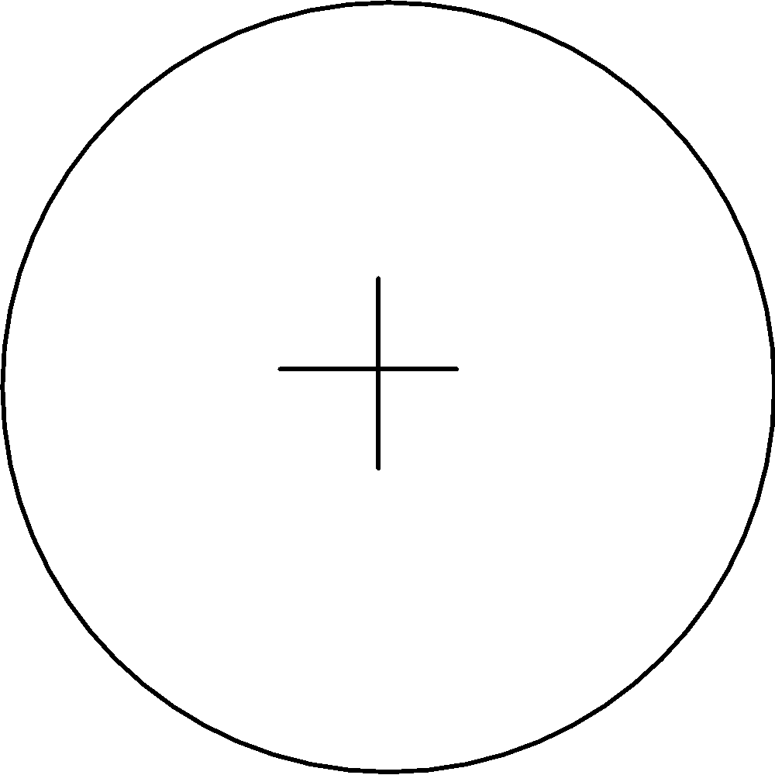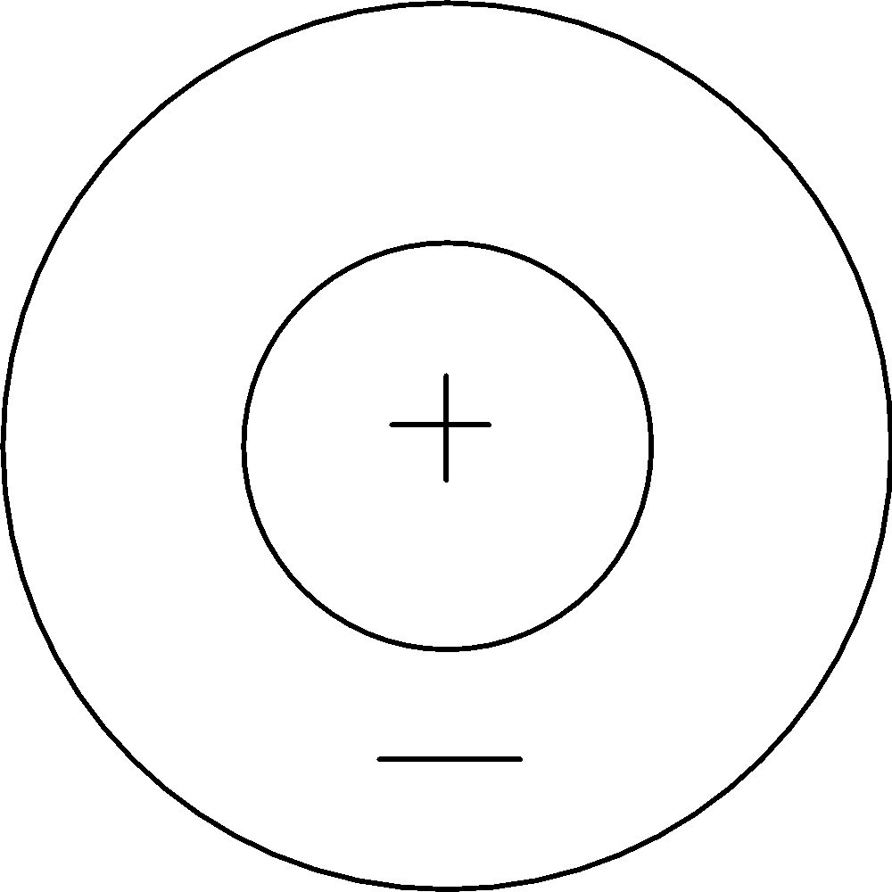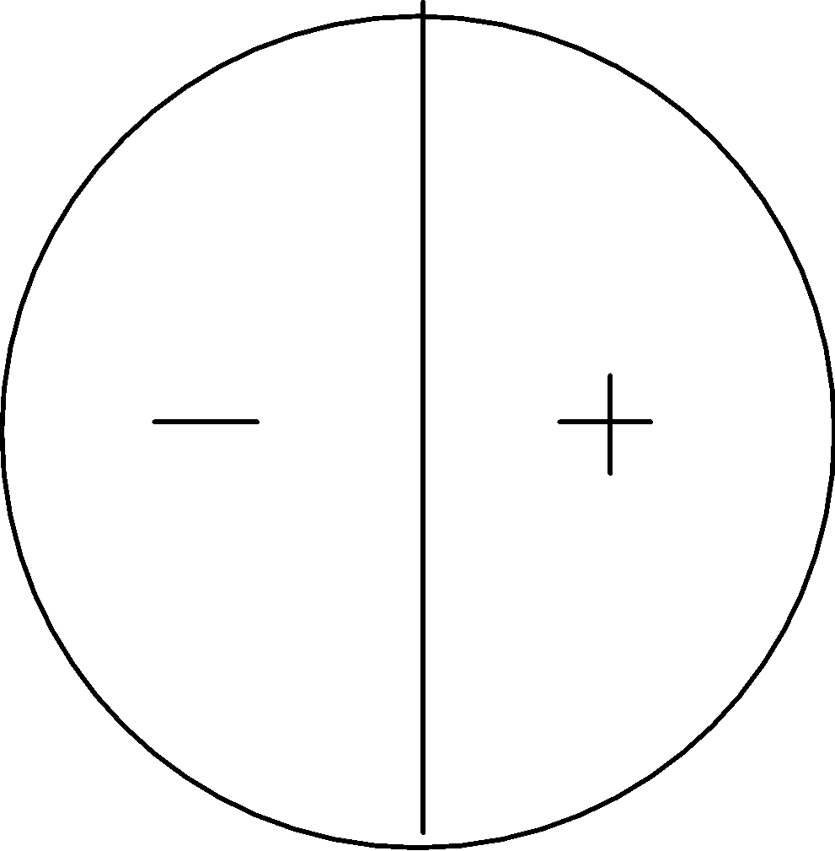

n = 1 k = 0 n = 2 k = 0 n = 2 k = 1

Fig. 5. The lowest three oscillation modes (energy levels) for a 2D membrane (drum skin)

OUP - Alternative illustration with graphics taken from :
https://www.google.com/url?sa=i&url=https%3A%2F%2Fwww.researchgate.net%2Ffigure%2FGreatly-exaggerated-mode-shapes-for-a-circular-membrane-with-radius-a-The-top-row_fig3_346002108&psig=AOvVaw2D_cYZRoabbRt-H2O5Acwj&ust=1711462510108000&source=images&cd=vfe&opi=89978449&ved=0CBIQjRxqFwoTCODi9uzMj4UDFQAAAAAdAAAAABAZ

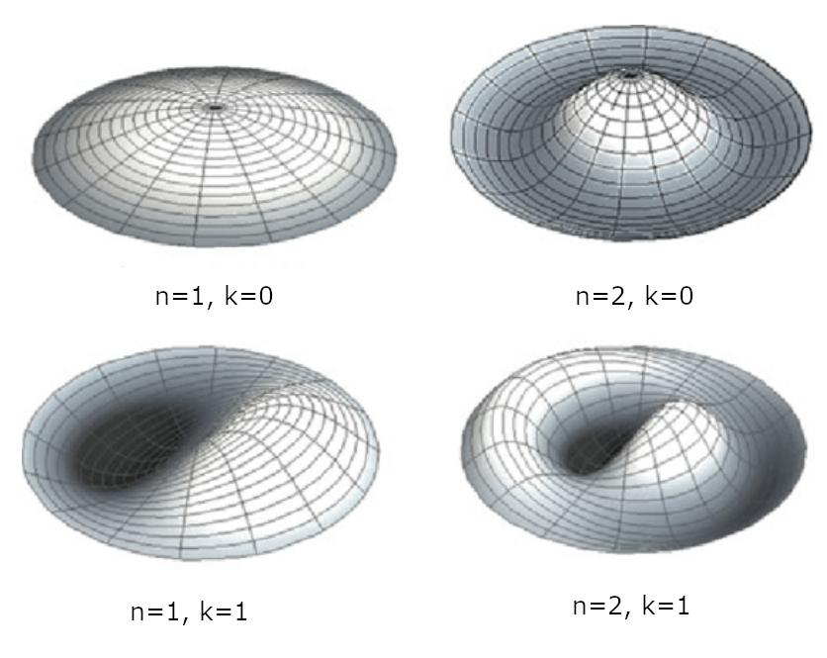
HUGH HAS SOME VERSIONS OF THESE IF NECESSARY

Figure 5 shows the first three oscillation modes for a drum skin. The lowest is symmetric with a peak at the origin and a wavelength of double the diameter. This corresponds to the ground state of the hydrogen atom. If we now increase the frequency, we obtain a mode with a wavelength equal to the diameter, but which is still symmetric. This corresponds to an electron in the next orbital, its mean position is about half-way out so is higher in energy. However, this also allows a solution varying with angle. This is the beginning of directional bonds. As the wavelength of the solutions decreases and the energy of the electron increases, the solutions move further out and more possibilities of angular variation become possible. This is how wave mechanics can explain the increasing complexity of atomic structure, starting with the hydrogen atom.

After this came Dirac and Feynman, and physics got difficult.

Reference

- ‘Sustainable Energy, Without the Hot Air’, David MacKay, 2016.

